Student Name: Ho Chi Chung Joe
Student ID: 20160970
Course: Executive Certificate in Applied AI and Predictive Analytics for Business (EP137)
Project Title: Use time series analysis to predict the stock index price by time-series analysis
Objective: To show how we can use the Time Series Analysis to do the simple prediction on the stock index price base on the time trend analysis of stock
Business Background: In classical economics, price is determinate by market demand and market supply, and all people are rational. The efficient market hypothesis states that share prices reflect all information and any attempt for prediction of the market is theoretically not possible. So, it is not possible to predict the price just based on the time. However, many investors believe that it is possible to predict the stock by technical analysis of the stock prices and trends. This project is trying to build a machine learning model to predict the stock price based on time-series analysis. So that we can know whether the stock index is predictable by just analysis the trends. In addition, we can know whether it is worth for us to refer the machine learning advise when we make investment.
Algorithm / Model used:
The Autoregressive Integrated Moving Average (ARIMA) model, which is a model based on both regression and moving average.
A ARMIA model formula is 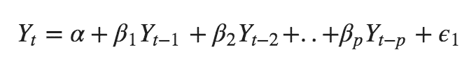
Y_{t-n} is a the lag of the series, beta is the coefficient of lag that model estimate, and alpha is the intercept term.
How to work it out:
We use python module yfinance to taken the figure on the stock price from yahoo finance
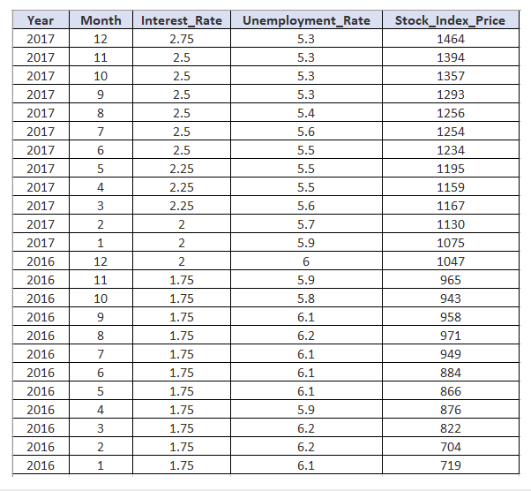

Checking for Linearity
Before we execute a linear regression model, it is advisable to validate that certain assumptions are met.
We need to check that a linear relationship exists between the dependent variable and the independent variable/s.
In our example, we may want to check that a linear relationship exists between the:
- Stock_Index_Price (dependent variable) and Interest_Rate (independent variable)
- Stock_Index_Price (dependent variable) and Unemployment_Rate (independent variable)
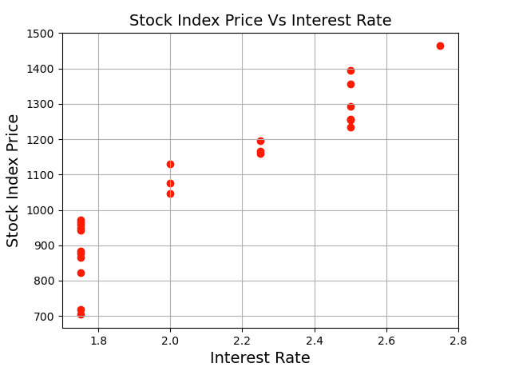
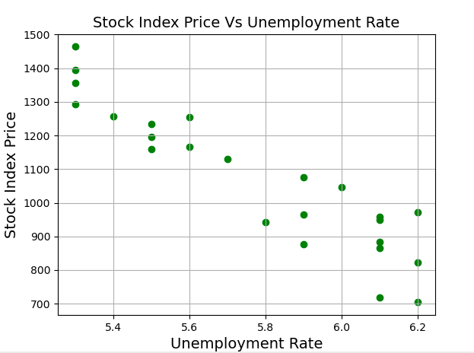

Performing the Multiple Linear Regression
First we need to add the data into Python, then we use both sklearn and statsmodels to get the regression results by the following code.
import pandas as pd
from sklearn import linear_model
import statsmodels.api as sm
Stock_Market = {'Year': [2017,2017,2017,2017,2017,2017,2017,2017,2017,2017,2017,2017,2016,2016,2016,2016,2016,2016,2016,2016,2016,2016,2016,2016],
'Month': [12, 11,10,9,8,7,6,5,4,3,2,1,12,11,10,9,8,7,6,5,4,3,2,1],
'Interest_Rate': [2.75,2.5,2.5,2.5,2.5,2.5,2.5,2.25,2.25,2.25,2,2,2,1.75,1.75,1.75,1.75,1.75,1.75,1.75,1.75,1.75,1.75,1.75],
'Unemployment_Rate': [5.3,5.3,5.3,5.3,5.4,5.6,5.5,5.5,5.5,5.6,5.7,5.9,6,5.9,5.8,6.1,6.2,6.1,6.1,6.1,5.9,6.2,6.2,6.1],
'Stock_Index_Price': [1464,1394,1357,1293,1256,1254,1234,1195,1159,1167,1130,1075,1047,965,943,958,971,949,884,866,876,822,704,719]
}

df = pd.DataFrame(Stock_Market,columns=['Year','Month','Interest_Rate','Unemployment_Rate','Stock_Index_Price'])

X = df[['Interest_Rate','Unemployment_Rate']] # here we have 2 variables for multiple regression. If you just want to use one variable for simple linear regression, then use X = df['Interest_Rate'] for example.Alternatively, you may add additional variables within the brackets
Y = df['Stock_Index_Price']

# with sklearn
regr = linear_model.LinearRegression()
regr.fit(X, Y)

print('Intercept: \n', regr.intercept_)
print('Coefficients: \n', regr.coef_)

# prediction with sklearn
New_Interest_Rate = 2.75
New_Unemployment_Rate = 5.3
print ('Predicted Stock Index Price: \n', regr.predict([[New_Interest_Rate ,New_Unemployment_Rate]]))

# with statsmodels
X = sm.add_constant(X) # adding a constant

model = sm.OLS(Y, X).fit()
predictions = model.predict(X)

print_model = model.summary()
print(print_model)

Result of the code
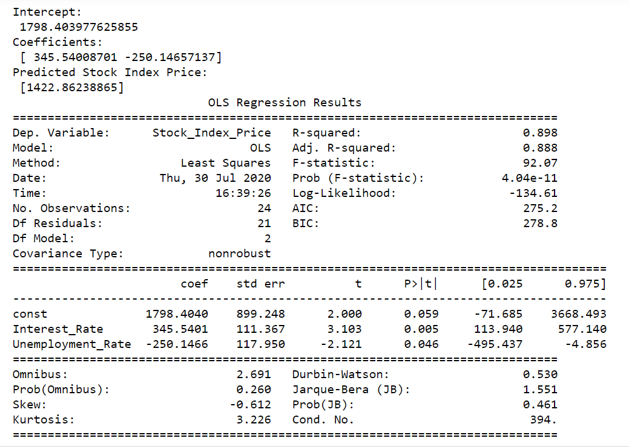

(1) The first part shows the output generated by sklearn:
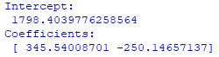
This output includes the intercept and coefficients. We can use this information to build the multiple linear regression equation as follows:
Stock_Index_Price = (Intercept)+(Interest_Rate coef)*X₁ +(Unemployment_Rate coef)*X₂

And once you plug the numbers:
Stock_Index_Price = (1798.4040) + (345.5401)*X₁ + (-250.1466)*X₂

(2) The second part displays the predicted output using sklearn:
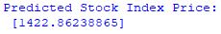
Imagine that we want to predict the stock index price after we collected the following data:
- Interest Rate = 2.75 (i.e., X₁= 2.75)
- Unemployment Rate = 5.3 (i.e., X₂= 5.3)

Then plug that data into the regression equation, we’ll get the same predicted result as displayed in the second part:
Stock_Index_Price = (1798.4040) + (345.5401)*(2.75) + (-250.1466)*(5.3) = 1422.86
Conclusion:
We have perform multiple linear regression in Python using both sklearn and statsmodels.

Before applying linear regression models, we need to make sure to check that a linear relationship exists between the dependent variable (i.e., what you are trying to predict) and the independent variable/s (i.e., the input variable/s).

End of the paper

